**UDF in hive**

Generally Hive having some Built-in functions, we can use that Built-in functions for our Hive program without adding any extra code but sometimes user requirement is not available in that built-in functions at that time user can write some own custom user defined functions called UDF (user defined function).Here is the simple steps of How To Write Hive UDF Example In Java.

Create java file 🡪 Add jars from usr/lib/hive/lib

This is a sample program to convert passed text to upper case

|  |
| --- |
| package com.hive.udf;  import org.apache.hadoop.hive.ql.exec.Description;  import org.apache.hadoop.hive.ql.exec.UDF;  import org.apache.hadoop.io.Text;  @Description(name = "myupper", value = "myupper(str) - Returns str with all characters changed to uppercase"  , extended = "Example:\n" + " > SELECT myupper('Facebook') FROM src_table")  public class MyUpper extends UDF{  public Text evaluate (Text s) {  if (s == null) return null;  return new Text (s.toString().toUpperCase());  }  } |

In eclipse right click on package name and click on Export..

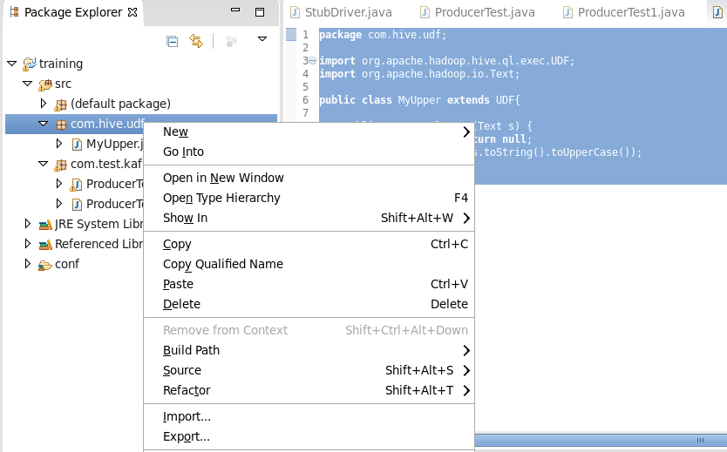

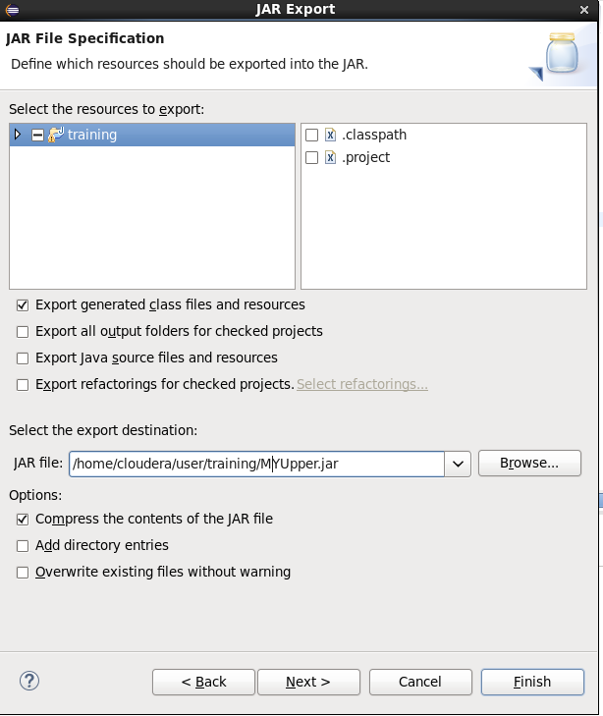

Click Finish to build MyUpper.jar file

Now come to hive prompt and add this jar to hive

|  |
| --- |
| add jar /home/cloudera/user/training/MYUpper.jar; |

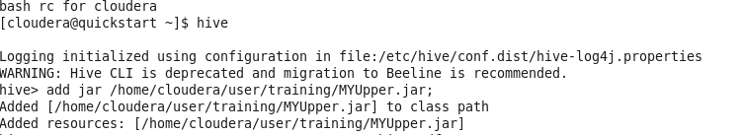

Now create a function in hive

|  |
| --- |
| hive> CREATE TEMPORARY FUNCTION myUpper AS 'com.hive.udf.MyUpper';  check by show functions command  hive > SHOW FUNCTIONS; |



Function is created , now you can use this function in hive, this is temporary function, scope of this function remain only within current hive session

Check below

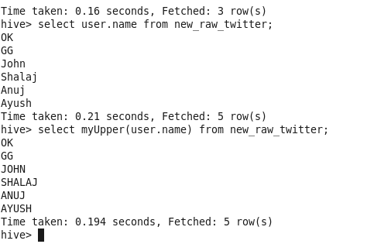

Below is the command to make permanent function in hive

|  |
| --- |
| CREATE FUNCTION myUpper AS 'com.hive.udf.MyUpper' USING JAR 'hdfs://172.27.155.92:8020/user/hive/udf/MYUpper.jar'; |

Note: you need to specify location using hdfs protocol

One more example

|  |
| --- |
| package com.hive.udf;  import org.apache.hadoop.hive.ql.exec.UDF;  import org.apache.hadoop.io.Text;  public class ReplaceChar extends UDF{    public Text evaluate(String str, String str1, String str2) {    Text result = new Text ();    String rep = str.replace(str1, str2);  result.set(rep);  return result;  }  } |

Create jar and export it to linux file system

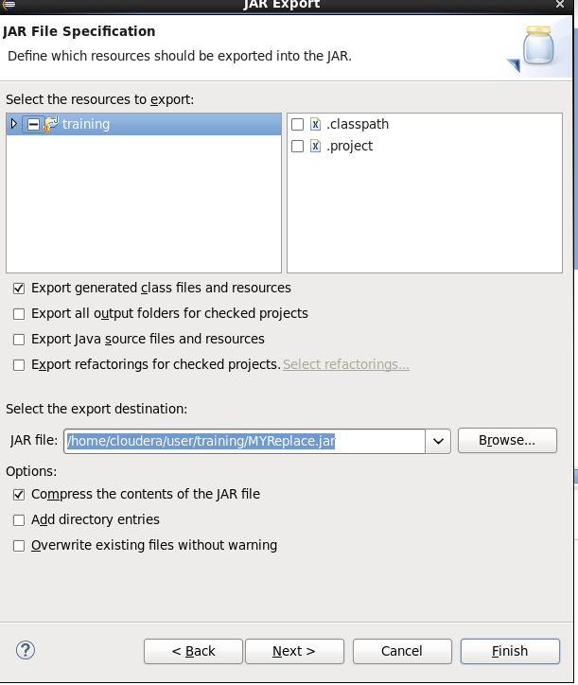

Now copy this jar to Hadoop file system

|  |
| --- |
| [cloudera@quickstart ~]$ hdfs dfs -put /home/cloudera/user/training/MYReplace.jar /user/cloudera/ |

Now open hive editor in HUE

Select normal query

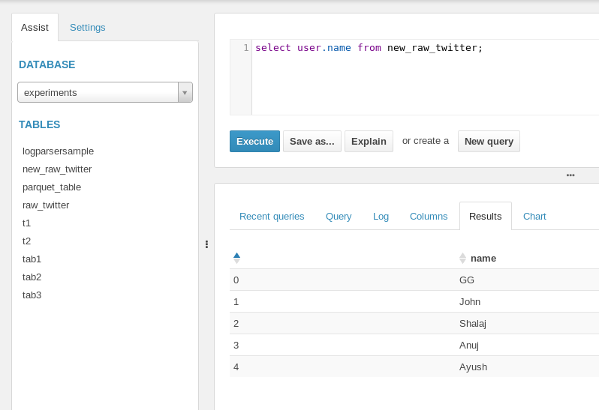

Now click on Settings tab and select jar file in File Resources section and name the function in UFDS section . Now in query tab use the function in query it works

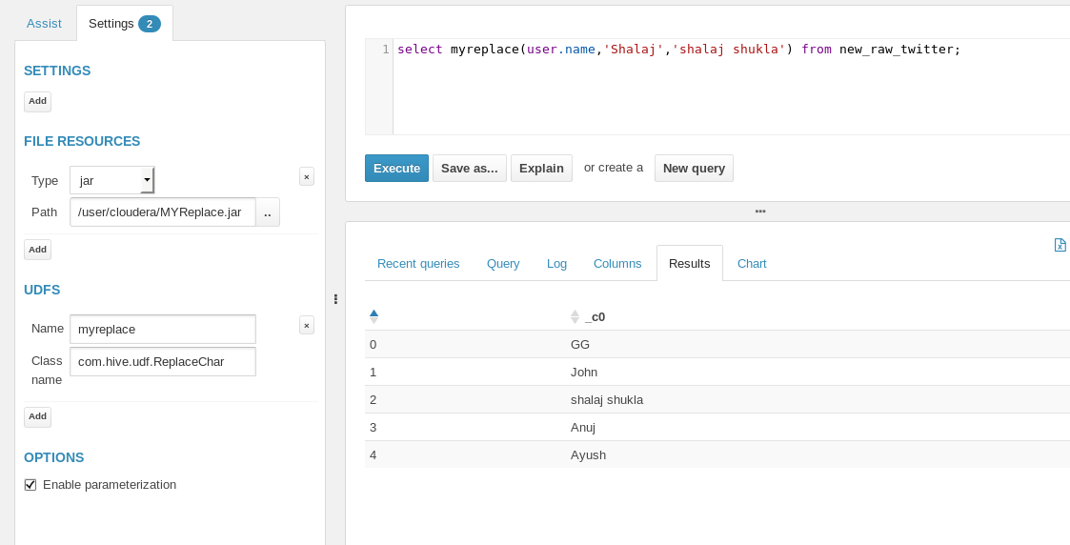

**UDF created in HUE doesn’t work in hive prompt and vice versa, need to check it**

**I think these functions are limited for session**